

# Final Report Summary: HEALTHCARE PORTFOLIO OPTIMIZATION USING MPT

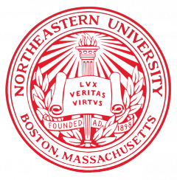

Ashutosh Singh

College of Professional Studies, Northeastern University

EAI 6050: Finance Information Processing

Prof. Zhi He

December 17, 2022

**Summary**

The goal of this study was to ascertain if the best potential portfolio is a fund or portfolio created using a market index of hazardous assets. This was studied by creating a fictitious ideal portfolio for the healthcare sectors of the US stock market and examining the investment weights in it (investment allocations). In-depth returns from actively managed sector-based funds in 2021 were also looked at in the study. Depending on the investigation, different results may be obtained, but the best-performing portfolios are those whose asset allocation is designed for long-term investing. The literature review of the paper explains the Modern Portfolio Theory (MPT), the efficient frontier and how it is generated, and how to obtain an optimal portfolio value. Mean-Variance Optimization and Hierarchical Risk Parity (HRP) are two algorithms I utilized to conduct my study because they are useful in portfolio optimization, which is the process of choosing assets such that the return on investment is maximized while the risk is minimized. Therefore, this is a very effective approach that allows us to improve the portfolio with fewer lines of code while simultaneously building a pipeline for future data. Other approaches, such as the mean conditional value at risk (mCVAR) and hierarchical risk parity (HRP), address some of the drawbacks of the mean-variance optimization approach. In particular, the covariance matrix, which measures how stock returns move in the same direction, does not need to be inverted in order for HRP to work. Because of how unpredictable the stock market is, nothing can be anticipated with certainty. To get to a final decision, I thus conducted certain fundamental analyses, including those of corporate reports, the economy, and industries. I want to convey my sincere gratitude to my instructor, Zhi He, to whom I am indebted for the priceless information I acquired via their lessons as well as for their insightful conversations and ongoing mentoring outside of office hours.